**PCF Login and generating logs**

* Login to PCF and Select the Org Name **RETAILEFORMS** and depending upon the below service, we must go to PCF logs
* eforms-editor-service-rb-natwest-dev
* eforms-email-integration-service-rb-natwest-dev
* eforms-runtime-service-rb-natwest-dev
* To get the PCF logs select the service and select the view in app metrics
* New pop up will be opened, select the time range and download the logs. These logs are of type gzip format. Unzip using 7-Zip.

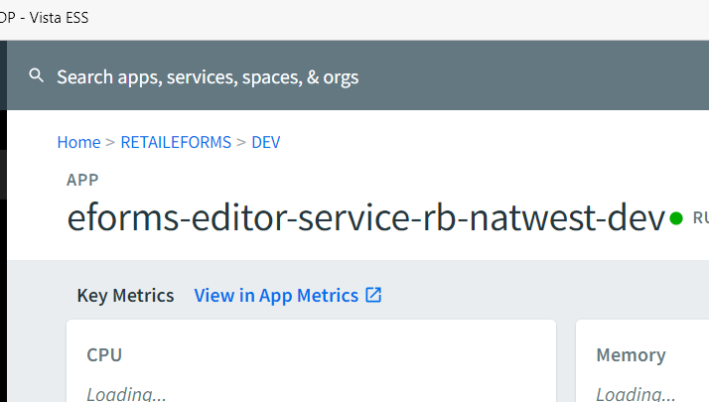

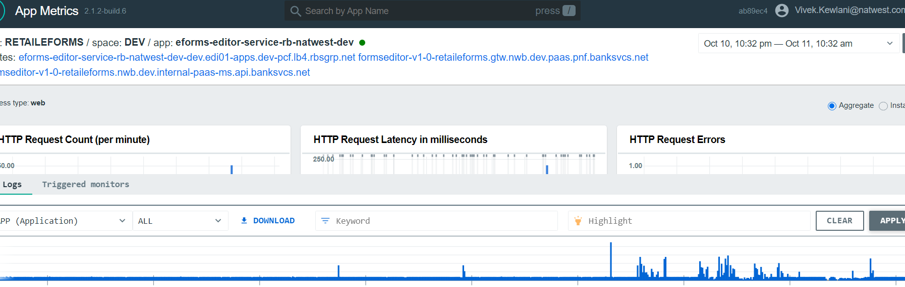

**Issues During UAT**

1. **Import form issues**

a) Inspect the element then and there and go to Network panel to see which api or service is getting hit

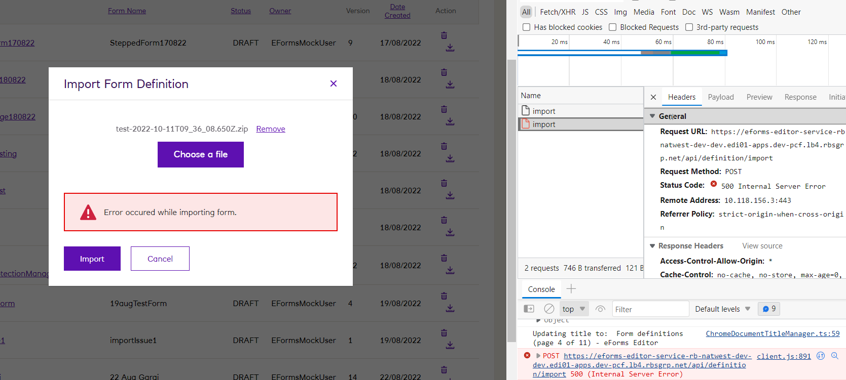b) Follow the PCF steps to generate the logs from editor service (eforms-editor-service-rb-natwest-dev)

c) Check the logs with the specific form name and search for the issue related to that and try to find line which might have thrown an exception

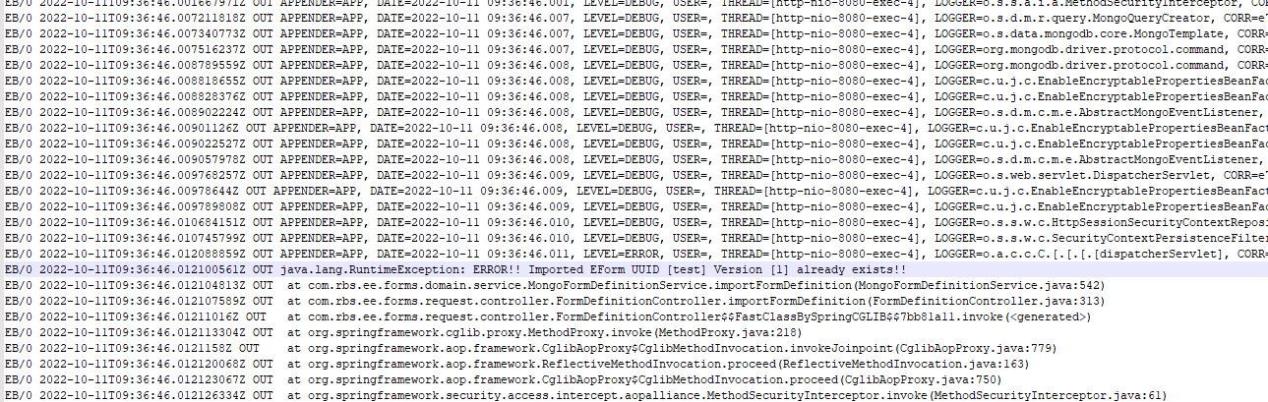

1. **Publish form issues**

a) Inspect the element then and there and go to Network panel to see which api or service is getting hit

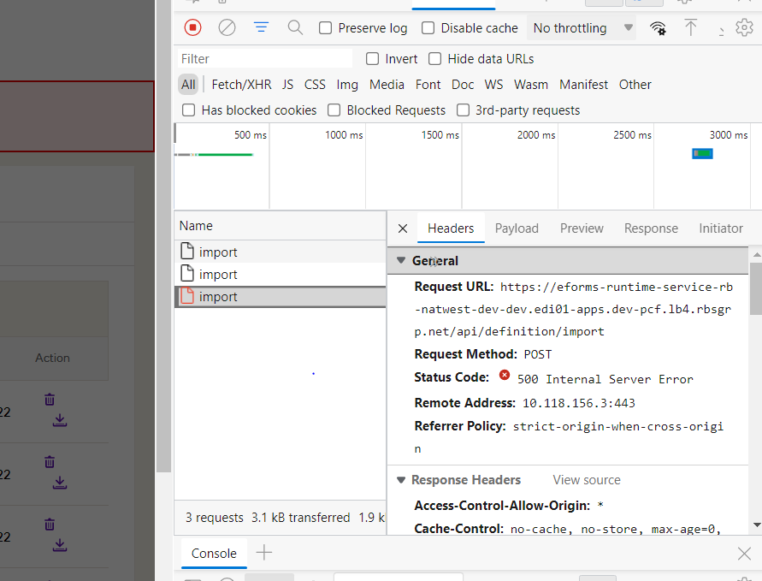

b) Follow the PCF steps to generate the logs from editor service (eforms-editor-service-rb-natwest-dev)

c) Check the logs with the specific form name and search for the issue related to that

1. **Delete from Runtime issue**
2. Check the editor logs
3. Search for the form name and try to locate the “non unique” associated with the form name.
4. Once located, you will get the table name where there are duplicate entries.
5. Go to mongo db and delete the duplicate entries
6. **Email trigger issue**

<https://confluence.dts.fm.rbsgrp.net/display/EFORMS/Troubleshooting+IronPort+Issues>

1. **Save button issue**



1. **Moving Component in the form**

Sequence of the components can be changed through “Developer mode” and “UI Schema”

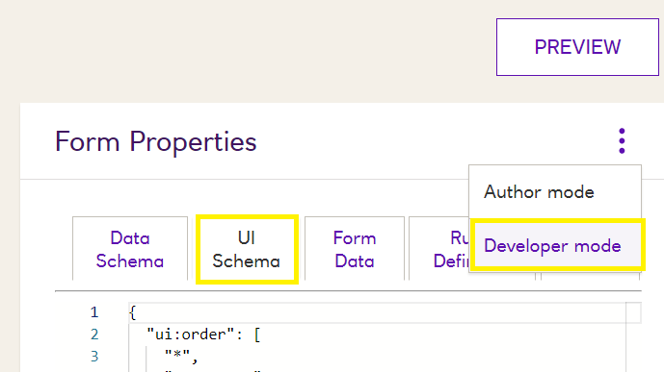

1. **FTL issue**

